**P3 – Explain the fundamentals of scripting language**

**Introduction**

In this report, I will explain the fundamentals of scripting languages.

**Scripting Language**

Scripting language is a high level programming language that supports scripts. A script is a set of instructions that is carried out by another program. Scripting language supports the set of instructions set by another program. The type of scripting language is the following:

* JavaScript
* Python
* PHP

**How it works within web page?**

Scripting language works by this being embedded within a web page to make it more functional for the user to use. Before scripting language was developed, there was only scripts. It was not functional as it is today. An example is different type of menus can enhance the way it looks now than it looked when scripting language was not developed.

**What types are available?**

Object Oriented is a type of feature that is available for scripting language. A method is used in object-oriented. As given examples above, they are many types of scripting language available. Python can be used for scripting language. Python is very versatile as it can be used with normal programming tasks and can be embedded within scripting language too. They are both the same and both do similar activities.

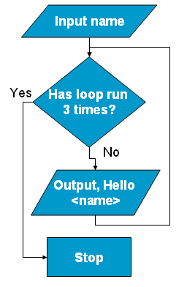**Main Features**

**Loop**

A loop is when you want the something to be done repeatedly. In JavaScript, a loop can use FOR or WHILE. These two can be used if they want two things to be done at the same time. For example, FOR the password to be complete, check if the password is complete. The picture shows how it works.

**Decision-making**

The decision-making is the choice of whether the program is making a good choice or not. Let us look at the flowchart for example. The decision the program has run 3 times more or not. 🡪

It would make a choice to continue the loop repeatedly or close it.

**Functions**

A function is a service used in programming. Various functions do different things depending on what the user has requested. The difference between Method and Functions is that the data for function can be used to operate on, whereas the piece of code that the instruction is set to do is called the method.

**Events**

An event is an action is successful. An example is shown below of creating a folder.

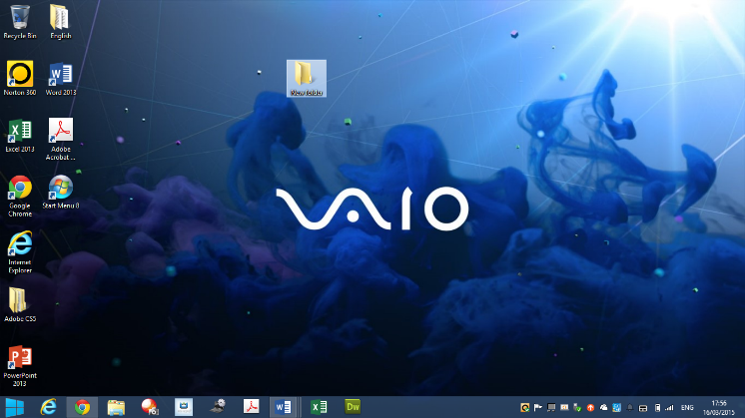

**Example**

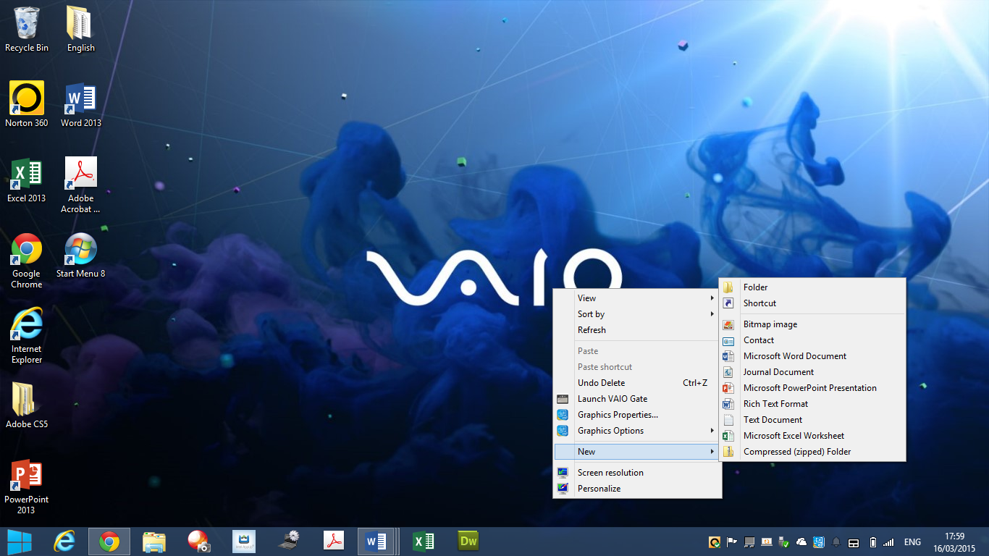

This is a desktop shown on Windows 8. The event that is taken place within this event-driven application is for the folder to be created on the desktop. To do this, the action is to use the mouse by clicking right-click. The trigger is, once you go on NEW 🡪 FOLDER, you click on it. The event is taken place by creating a folder.

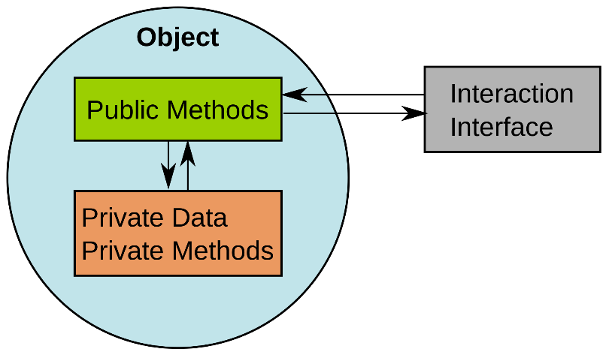**Methods**

A method is associated with a class. A method uses the class to control to what the object will end up doing. It really depends what the object is about. If the object is about cars, the method will be either to make the car accelerate, or decelerate; which would be one.

**Properties**

In object-oriented programming, properties can be involved in heavily. The properties can change the whole program and can have an effect on the rest of the program. For example, it can confuse one programmer if not used properly. If I were to change the boxes to different names, but I did not change it on the code; it would create errors. The user needs to check the properties of the box to change it to its original or change the code.

**Describe and Example**

**Maintaining Cookies**

Cookies are small text files, which are used to redirect the user to the page again once the system has been shut down.

**Example**

**Cookies can be created using the following code:**  
function createCookie(name,value,days) {   
if (days) {   
var date = new Date();   
date.setTime(date.getTime()+(days*24*60*60*1000));   
var expires = "; expires="+date.toGMTString();   
}   
else var expires = "";   
document.cookie = name+"="+value+expires+"; path=/";   
}  
**Cookies can be read using the following code:**function readCookie(name) {  
var nameEQ = name + "=";   
var ca = document.cookie.split(';');   
for(var i=0;i < ca.length;i++) {   
var c = ca[i];   
while (c.charAt(0)==' ') c = c.substring(1,c.length);  
if (c.indexOf(nameEQ) == 0) return c.substring(nameEQ.length,c.length);   
}   
return null; }  
**Cookies can be erased using the following code:**

function eraseCookie(name) {   
createCookie(name,"",-1);

**Creating rollovers**

Rollovers is usually found on most websites where the user moves the cursor over the image and it changes to another one. To do this in JavaScript, the user has to follow the steps.

To create the movement mouse effect, the following code is implemented.

<a href="index.html"  
  onmouseover="buttondown('homebutton')"  
  onmouseout="buttonup('homebutton')">  
<img src="homebutton.gif" name="homebutton" border="0" />  
</a>

**Prompting the user**

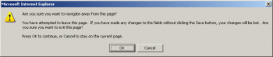Prompting the user is to persuade the user to do something. An example is shown on the picture. As you can see, it persuades the user to make sure he/she wants to continue out of the web page. To do this, you need to type the code in below.

<script language="JavaScript">

**var needToConfirm = true;**

window.onbeforeunload = confirmExit;

function confirmExit()

{

**if (needToConfirm)**

return *message to display in dialog box*;

}

</script>

...

<input type="Submit" value="Save" **onclick="needToConfirm = false;"** />

**Redirecting the user**

This is when you send the person on to another page once it has been complete with one page. For example, if I were to send an email to another person, I send the email; it would redirect me to the Inbox page. This is an example.

/**

* Print a redirect screen

*

* @param string Text to display on the redirect screen

* @param string URL to direct to

* @param string SEO Title

* @param string SEO Template

* @return string

*/

public function redirectScreen( $text="", $url="", $seoTitle="", $seoTemplate='' )

**M2 – Discuss how a scripting language can improve functionality**

**Introduction**

In this report, I will explain the advantages and disadvantages of scripting language. I will also explain how scripting language can be improved with its functionality.

[](http://www.google.co.uk/url?sa=i&rct=j&q=&esrc=s&source=images&cd=&cad=rja&uact=8&ved=0CAcQjRxqFQoTCL_izsWNlMYCFa0X2wodHiEAPg&url=http%3A%2F%2Fwww.acpcomputer.edu.sg%2Findex.php%2Fadvantages-and-disadvantages-of-e-learning%2F&ei=6QeAVf_JAq2v7AaewoDwAw&bvm=bv.96041959,d.ZGU&psig=AFQjCNEbzhXl7ZILEiXkGSqhCqdj6st-ag&ust=1434540389849752)**Advantage**

* Easy to learn
* Minimum background on programming required
* Simple
* Fast editing for code

Learning scripting language is very easy. Anyone can learn it. It is very simple and fast.

[](http://www.google.co.uk/url?sa=i&rct=j&q=&esrc=s&source=images&cd=&cad=rja&uact=8&ved=0CAcQjRxqFQoTCL_izsWNlMYCFa0X2wodHiEAPg&url=http%3A%2F%2Fwww.acpcomputer.edu.sg%2Findex.php%2Fadvantages-and-disadvantages-of-e-learning%2F&ei=6QeAVf_JAq2v7AaewoDwAw&bvm=bv.96041959,d.ZGU&psig=AFQjCNEbzhXl7ZILEiXkGSqhCqdj6st-ag&ust=1434540389849752)**Disadvantage**

* Usually runs quite slow
* Limited commands

**Improvement**

Improvements made to scripting language can be to add other features that can enable users to move around the website more freely. A feature that can be improved is by using rollovers. Scripting language is only used to create simple tasks and it helps HTML improve the function. However, by using rollovers, it can make harder tasks be implemented.

*Rollovers is usually found on most websites where the user moves the cursor over the image and it changes to another one. To do this, the user needs to create the effect from the cursor change. Then, the user needs to change the picture. Once these two steps are complete, rollovers is successful.*

By adding rollovers, it can improve the functionality. This means, if one person is shopping online, and a user can move its cursor around to a picture, it can automatically recognise the change and enlarge the picture. These types of functionality can improve one.

[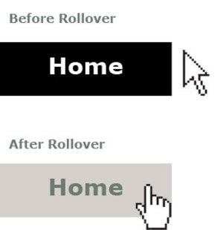](http://www.google.co.uk/url?sa=i&rct=j&q=&esrc=s&source=images&cd=&cad=rja&uact=8&ved=0CAcQjRxqFQoTCNaVp4aNlMYCFQIJ2wodcaYAhg&url=http%3A%2F%2Fwebsitedersleri.tr.gg%2Frollover-image.htm&ei=ZAeAVdbTEIKS7AbxzIKwCA&bvm=bv.96041959,d.ZGU&psig=AFQjCNEdHh4BJRbDstCxbj4AEdgN0GiftA&ust=1434540258728286)